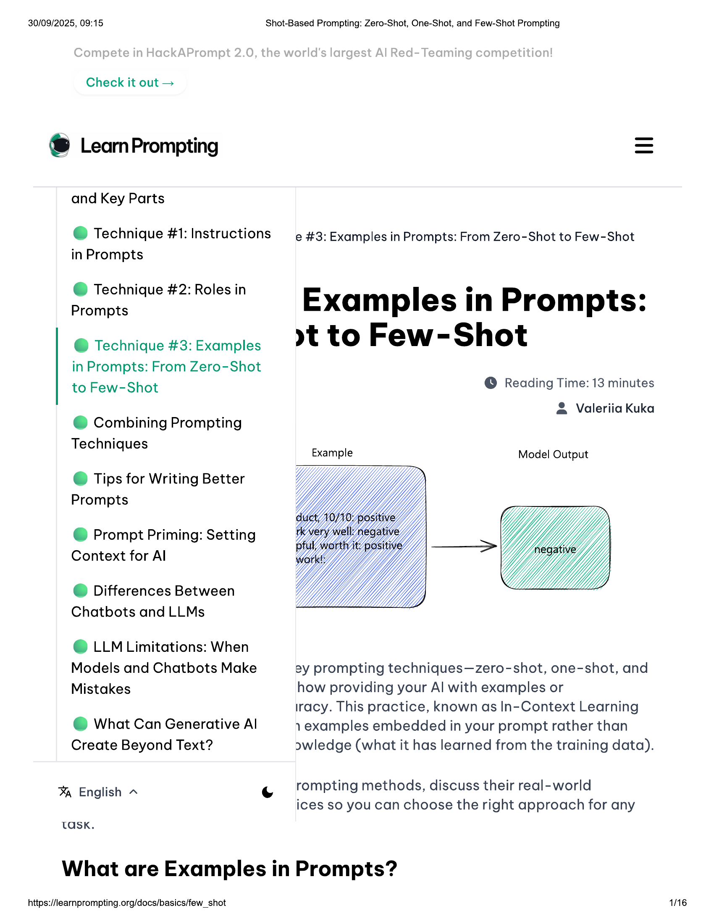

30/09/2025, 09:15  
  
Check it out >  
  
®& LeamPrompting  
  
and Key Parts  
  
@ Technique #1: Instructions  
in Prompts  
  
@ Technique #2: Roles in  
Prompts  
  
@ Technique #3: Examples  
in Prompts: From Zero-Shot  
to Few-Shot  
  
@ Combining Prompting  
Techniques  
  
© Tips for Writing Better  
Prompts  
  
@ Prompt Priming: Setting  
Context for Al  
  
© Differences Between  
Chatbots and LLMs  
  
© LLM Limitations: When  
Models and Chatbots Make  
Mistakes  
  
@ What Can Generative Al  
Create Beyond Text?  
  
Shot-Based Prompting: Zero-Shot, One-Shot, and Few-Shot Prompting  
  
e #3: Examples in Prompts: From Zero-Shot to Few-Shot  
  
Examples in Prompts:  
»t to Few-Shot  
  
© Reading Time: 13 minutes  
  
& Valeriia Kuka  
  
Model Output  
  
2y prompting techniques—zero-shot, one-shot, and  
how providing your Al with examples or  
  
racy. This practice, known as In-Context Learning  
  
1 examples embedded in your prompt rather than  
awledge (what it has learned from the training data).  
  
rompting methods, discuss their real-world  
  
% English ~ ee |. .  
ices so you can choose the right approach for any  
  
TASK.  
  
What are Examples in Prompts?  
  
https://learnprompting.org/docs/basics/few_shot 1/16

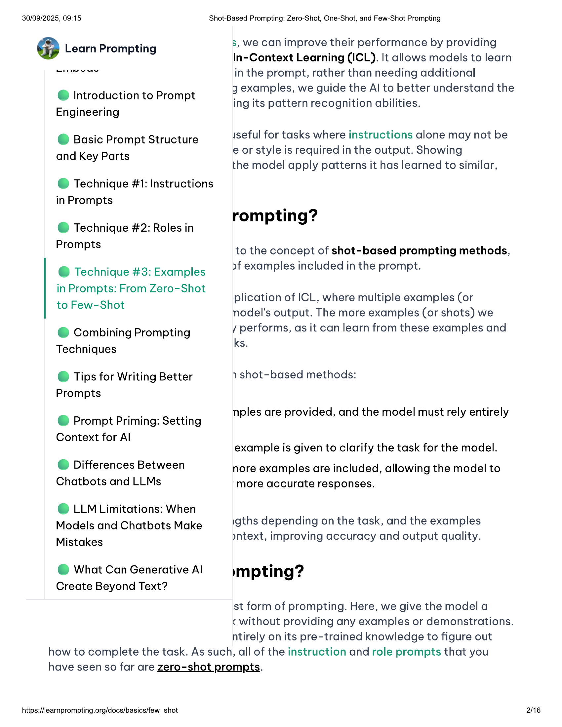

30/09/2025, 09:15 Shot-Based Prompting: Zero-Shot, One-Shot, and Few-Shot Prompting  
  
@ Learn Prompting 3, we can improve their performance by providing  
In-Context Learning (ICL). It allows models to learn  
  
Strienens in the prompt, rather than needing additional  
jy examples, we guide the Al to better understand the  
  
Introduction to Prompt an wa wae  
e P ing its pattern recognition abilities.  
  
Engineering  
iseful for tasks where instructions alone may not be  
  
e or style is required in the output. Showing  
the model apply patterns it has learned to similar,  
  
© Basic Prompt Structure  
and Key Parts  
  
@ Technique #1: Instructions  
in Prompts  
  
rompting?  
@ Technique #2: Roles in  
  
Prompts to the concept of shot-based prompting methods,  
  
@ Technique #3: Examples >f examples included in the prompt.  
  
in Prompts: From Zero-Shot  
  
to Few-Shot plication of ICL, where multiple examples (or  
  
nodel's output. The more examples (or shots) we  
  
@ Combining Prompting y performs, as it can learn from these examples and  
  
Techniques ks.  
©@ Tips for Writing Better 1 shot-based methods:  
Prompts  
  
nples are provided, and the model must rely entirel  
@ Prompt Priming: Setting P P y y  
  
Context for Al , .  
  
example is given to clarify the task for the model.  
© Differences Between nore examples are included, allowing the model to  
Chatbots and LLMs "more accurate responses.  
  
© LLM Limitations: When  
Models and Chatbots Make igths depending on the task, and the examples  
  
Mistakes yntext, improving accuracy and output quality.  
  
© What Can Generative Al impting?  
  
Create Beyond Text?  
st form of prompting. Here, we give the model a  
< without providing any examples or demonstrations.  
ntirely on its pre-trained knowledge to figure out  
  
how to complete the task. As such, all of the instruction and role prompts that you  
have seen so far are zero-shot prompts.  
  
https://learnprompting.org/docs/basics/few_shot 2/16

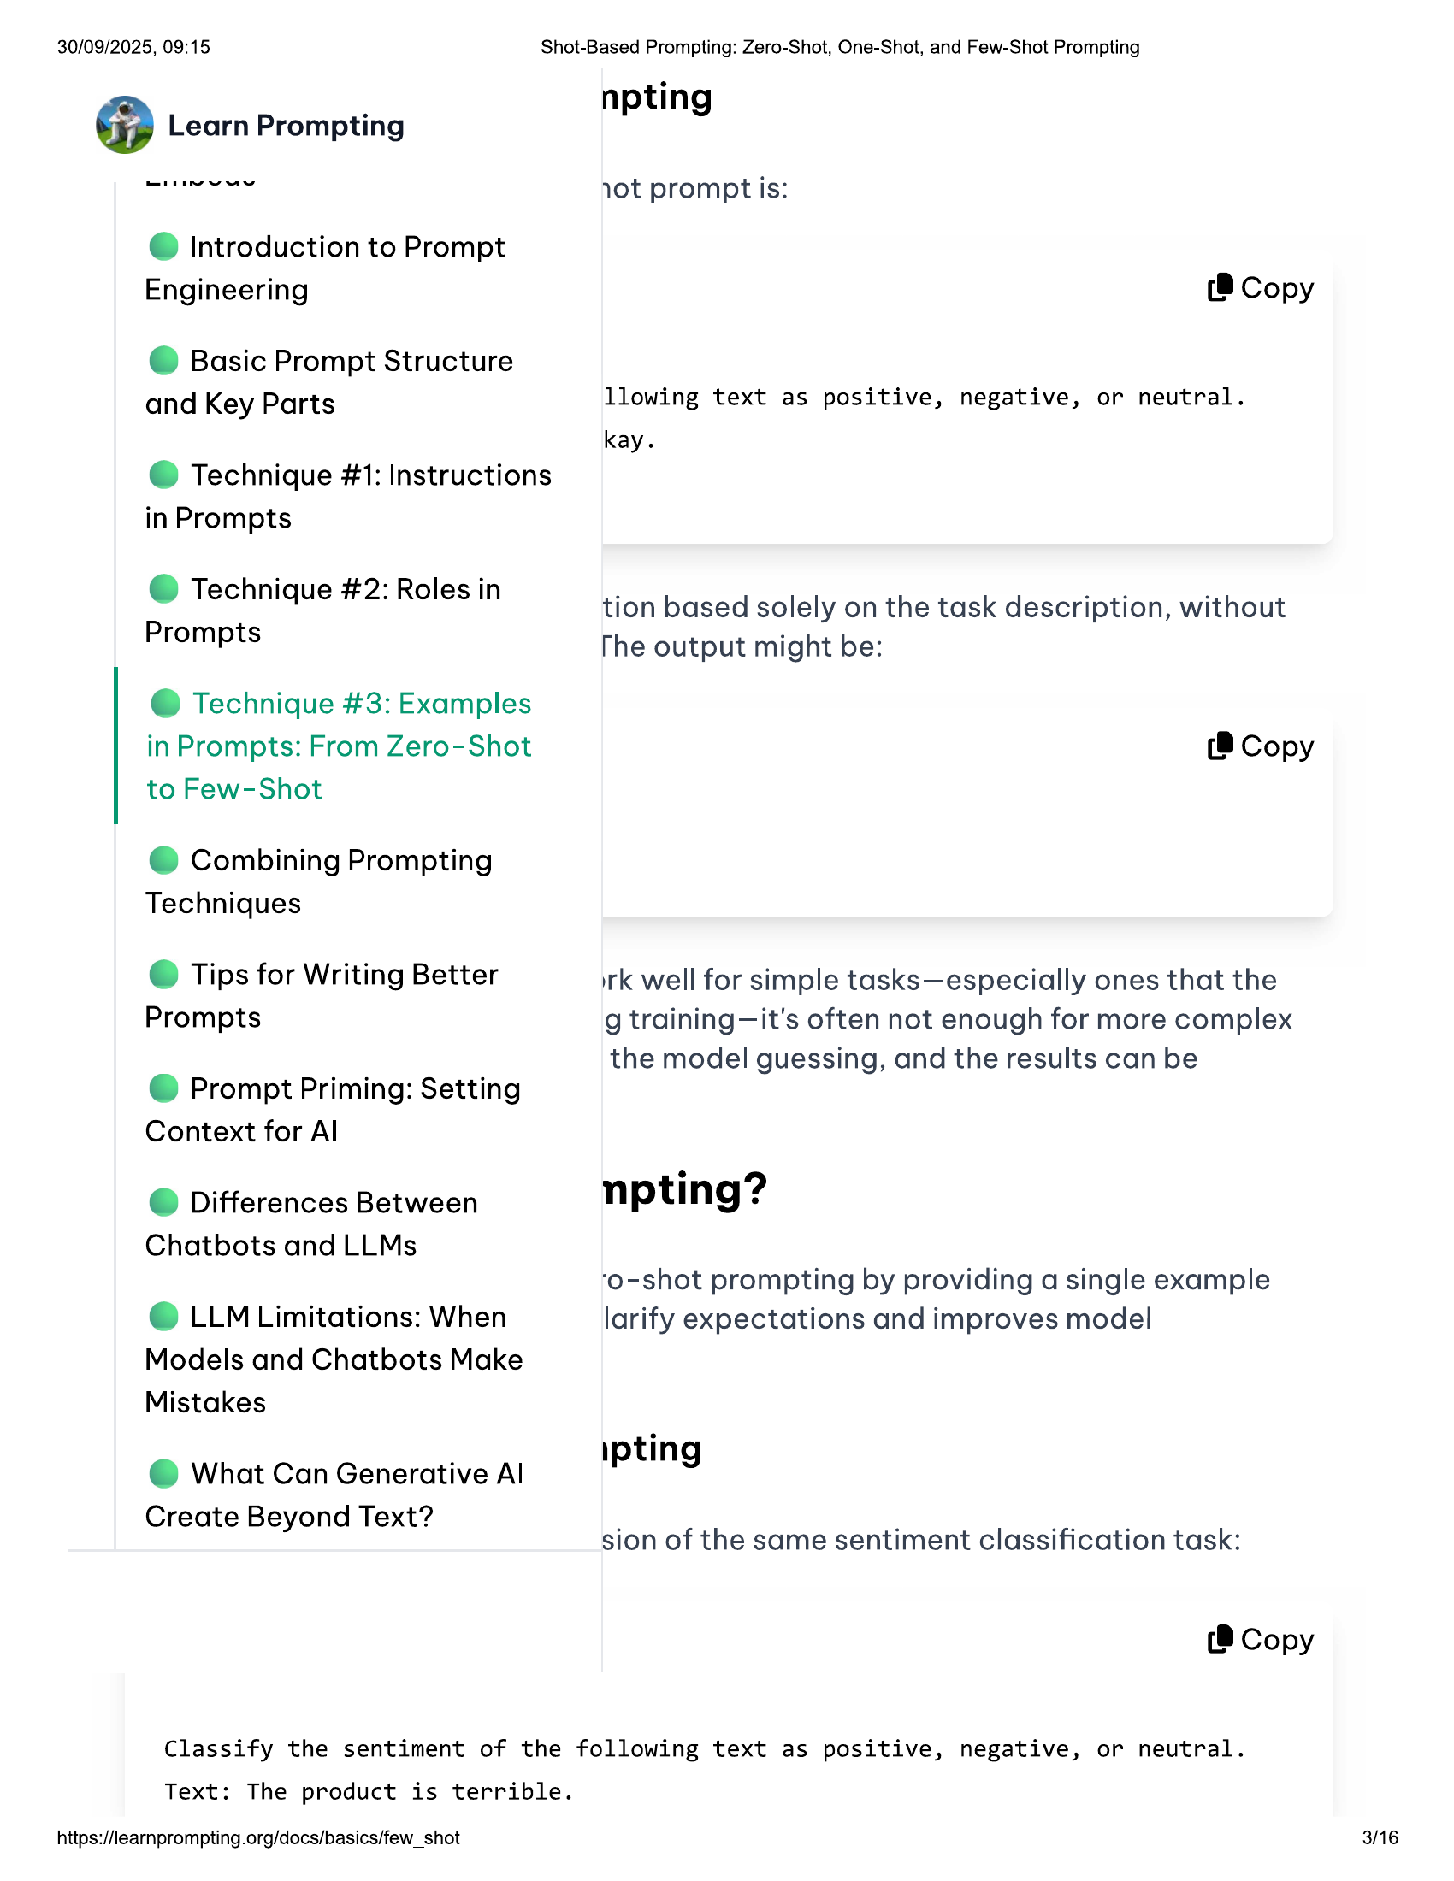

30/09/2025, 09:15  
  
@ Introduction to Prompt  
Engineering  
  
© Basic Prompt Structure  
and Key Parts  
  
@ Technique #1: Instructions  
in Prompts  
  
@ Technique #2: Roles in  
Prompts  
  
@ Technique #3: Examples  
in Prompts: From Zero-Shot  
to Few-Shot  
  
@ Combining Prompting  
Techniques  
  
© Tips for Writing Better  
Prompts  
  
@ Prompt Priming: Setting  
Context for Al  
  
@ Differences Between  
Chatbots and LLMs  
  
© LLM Limitations: When  
Models and Chatbots Make  
Mistakes  
  
@ What Can Generative Al  
Create Beyond Text?  
  
Shot-Based Prompting: Zero-Shot, One-Shot, and Few-Shot Prompting  
  
npting  
vot prompt is:  
  
(8 Copy  
  
llowing text as positive, negative, or neutral.  
  
kay.  
  
tion based solely on the task description, without  
The output might be:  
  
(® Copy  
  
irk well for simple tasks—especially ones that the  
g training—it's often not enough for more complex  
the model guessing, and the results can be  
  
npting?  
  
‘o-shot prompting by providing a single example  
larify expectations and improves model  
  
ipting  
  
sion of the same sentiment classification task:  
  
(8 Copy  
  
Classify the sentiment of the following text as positive, negative, or neutral.  
  
Text: The product is terrible.  
  
https://learnprompting.org/docs/basics/few_shot  
  
3/16

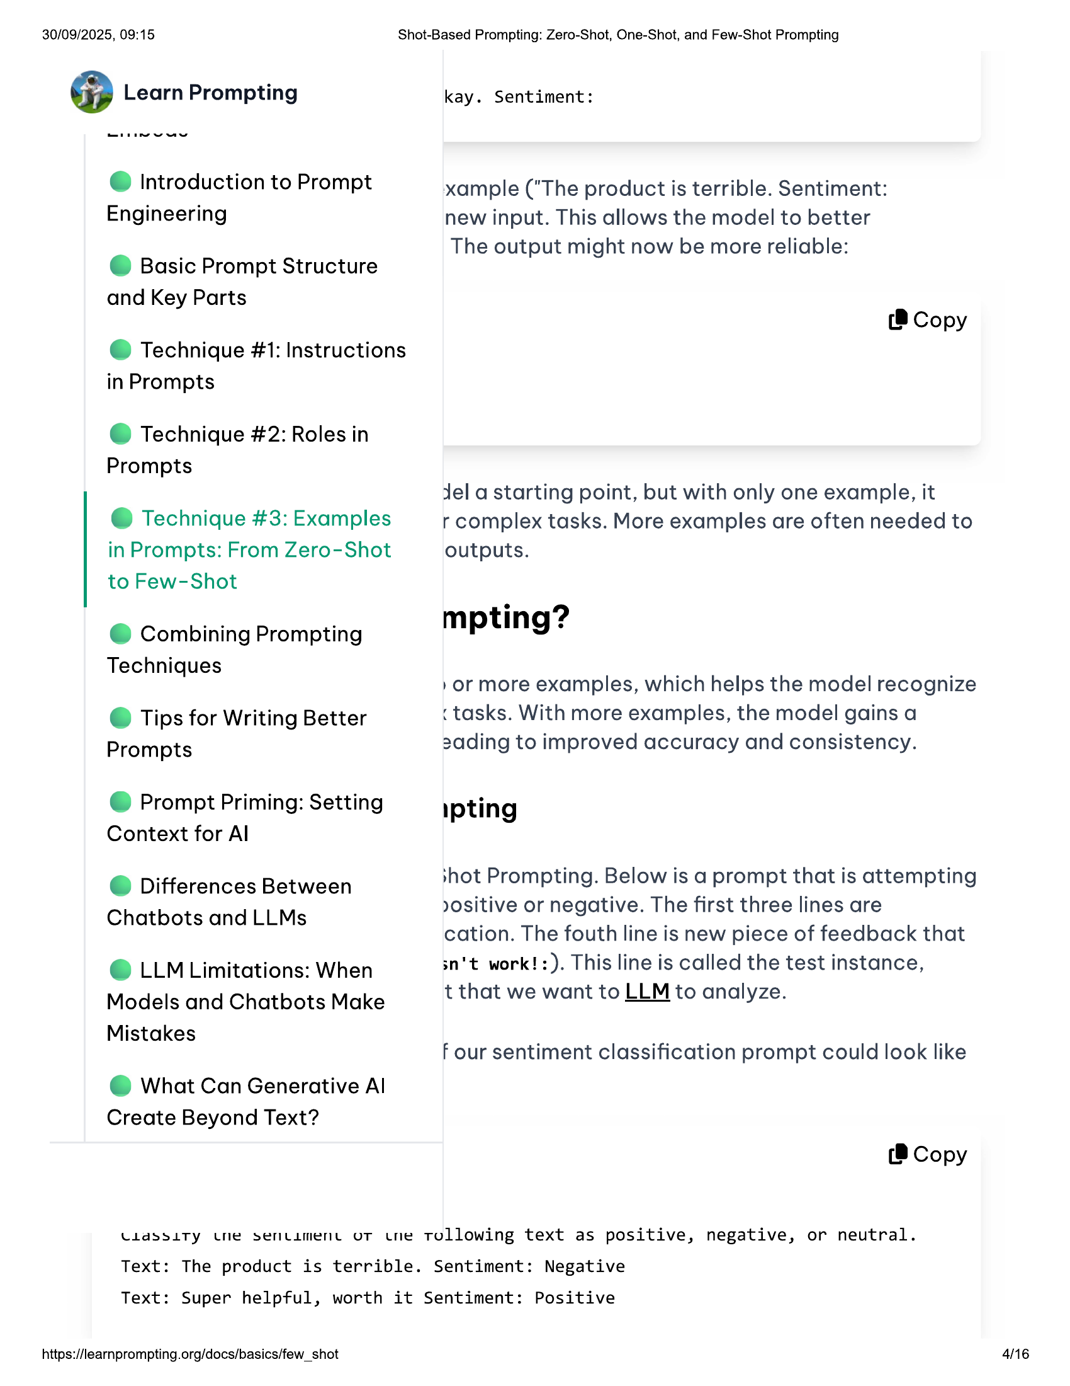

30/09/2025, 09:15  
  
@ Introduction to Prompt  
Engineering  
  
© Basic Prompt Structure  
and Key Parts  
  
@ Technique #1: Instructions  
in Prompts  
  
@ Technique #2: Roles in  
Prompts  
  
@ Technique #3: Examples  
in Prompts: From Zero-Shot  
to Few-Shot  
  
@ Combining Prompting  
Techniques  
  
© Tips for Writing Better  
Prompts  
  
@ Prompt Priming: Setting  
Context for Al  
  
@ Differences Between  
Chatbots and LLMs  
  
© LLM Limitations: When  
Models and Chatbots Make  
Mistakes  
  
@ What Can Generative Al  
Create Beyond Text?  
  
Shot-Based Prompting: Zero-Shot, One-Shot, and Few-Shot Prompting  
  
kay. Sentiment:  
  
xample ("The product is terrible. Sentiment:  
new input. This allows the model to better  
The output might now be more reliable:  
  
(® Copy  
  
jel a starting point, but with only one example, it  
r complex tasks. More examples are often needed to  
outputs.  
  
mpting?  
/or more examples, which helps the model recognize  
  
< tasks. With more examples, the model gains a  
2ading to improved accuracy and consistency.  
  
ipting  
  
»hot Prompting. Below is a prompt that is attempting  
yositive or negative. The first three lines are  
  
cation. The fouth line is new piece of feedback that  
sn't work!:). This line is called the test instance,  
  
t that we want to LLM to analyze.  
  
f our sentiment classification prompt could look like  
  
(8 Copy  
  
UlassutTy tne senciment ot tne tollowing text as positive, negative, or neutral.  
  
Text: The product is terrible. Sentiment: Negative  
  
Text: Super helpful, worth it Sentiment: Positive  
  
https://learnprompting.org/docs/basics/few_shot  
  
416

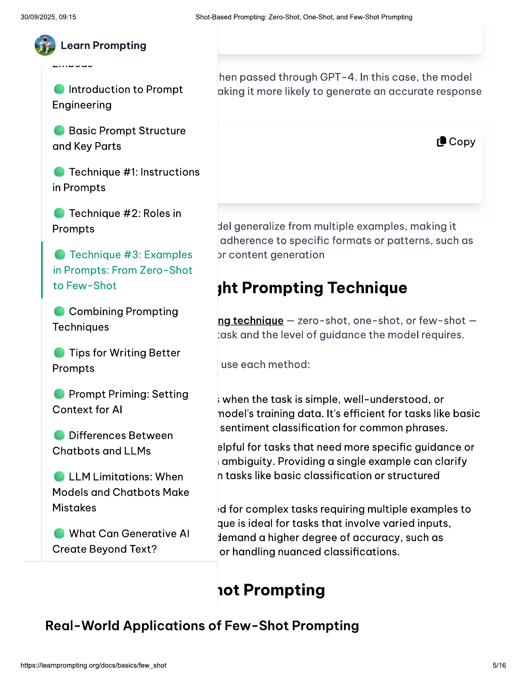

30/09/2025, 09:15  
  
@ Introduction to Prompt  
Engineering  
  
© Basic Prompt Structure  
and Key Parts  
  
@ Technique #1: Instructions  
in Prompts  
  
@ Technique #2: Roles in  
Prompts  
  
@ Technique #3: Examples  
in Prompts: From Zero-Shot  
to Few-Shot  
  
@ Combining Prompting  
Techniques  
  
© Tips for Writing Better  
Prompts  
  
@ Prompt Priming: Setting  
Context for Al  
  
@ Differences Between  
Chatbots and LLMs  
  
© LLM Limitations: When  
Models and Chatbots Make  
Mistakes  
  
@ What Can Generative Al  
Create Beyond Text?  
  
Shot-Based Prompting: Zero-Shot, One-Shot, and Few-Shot Prompting  
  
hen passed through GPT -4. In this case, the model  
aking it more likely to generate an accurate response  
  
(® Copy  
  
del generalize from multiple examples, making it  
adherence to specific formats or patterns, such as  
2r content generation  
  
yht Prompting Technique  
  
ng technique — zero-shot, one-shot, or few-shot —  
ask and the level of guidance the model requires.  
  
use each method:  
  
; when the task is simple, well-understood, or  
nodel's training data. It's efficient for tasks like basic  
sentiment classification for common phrases.  
  
alpful for tasks that need more specific guidance or  
| ambiguity. Providing a single example can clarify  
n tasks like basic classification or structured  
  
:d for complex tasks requiring multiple examples to  
que is ideal for tasks that involve varied inputs,  
Jemand a higher degree of accuracy, such as  
  
or handling nuanced classifications.  
  
10t Prompting  
  
Real-World Applications of Few-Shot Prompting  
  
https://learnprompting.org/docs/basics/few_shot  
  
5/16

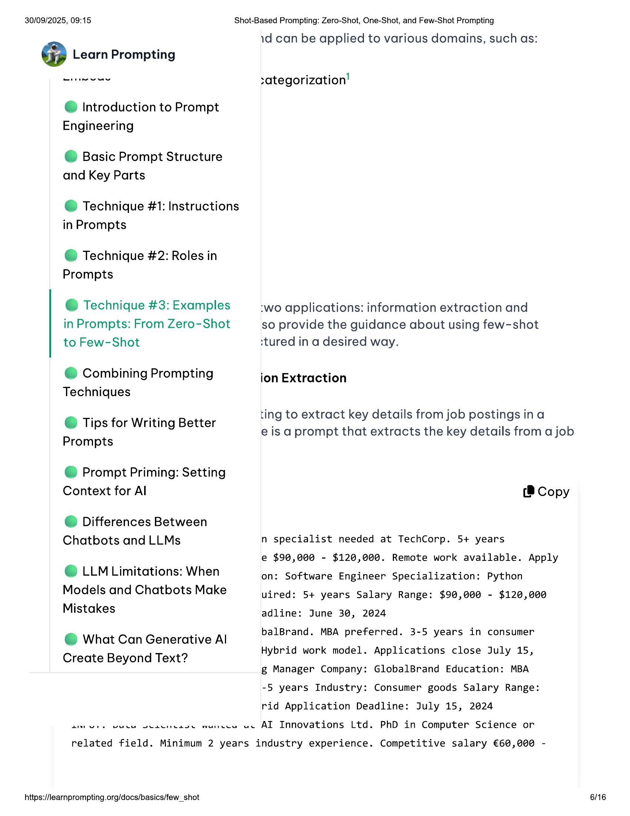

30/09/2025, 09:15 Shot-Based Prompting: Zero-Shot, One-Shot, and Few-Shot Prompting  
id can be applied to various domains, such as:  
  
wie eee :ategorization'  
  
@ Introduction to Prompt  
Engineering  
  
© Basic Prompt Structure  
and Key Parts  
  
@ Technique #1: Instructions  
in Prompts  
  
@ Technique #2: Roles in  
  
Prompts  
  
@ Technique #3: Examples :wo applications: information extraction and  
in Prompts: From Zero-Shot so provide the guidance about using few-shot  
to Few-Shot stured in a desired way.  
  
@ Combining Prompting ion Extraction  
  
Techniques  
  
ting to extract key details from job postings ina  
  
Tips for Writing Better . . .  
@ Tip ning eis a prompt that extracts the key details from a job  
  
Prompts  
  
@ Prompt Priming: Setting  
  
Context for Al (® Copy  
@ Differences Between  
Chatbots and LLMs n specialist needed at TechCorp. 5+ years  
  
e $90,000 - $120,000. Remote work available. Apply  
e LLM Limitations: When on: Software Engineer Specialization: Python  
Models and Chatbots Make uired: 5+ years Salary Range: $90,000 - $120,000  
Mistakes adline: June 30, 2024  
  
: balBrand. MBA preferred. 3-5 years in consumer  
@ What Can Generative Al P y  
  
Create Beyond Text? Hybrid work model. Applications close July 15,  
  
g Manager Company: GlobalBrand Education: MBA  
-5 years Industry: Consumer goods Salary Range:  
rid Application Deadline: July 15, 2024  
  
aN Ure VuLe Seacnease wurecu ue AI Innovations Ltd. PhD in Computer Science or  
  
related field. Minimum 2 years industry experience. Competitive salary €60,000 -  
  
https://learnprompting.org/docs/basics/few_shot  
  
6/16

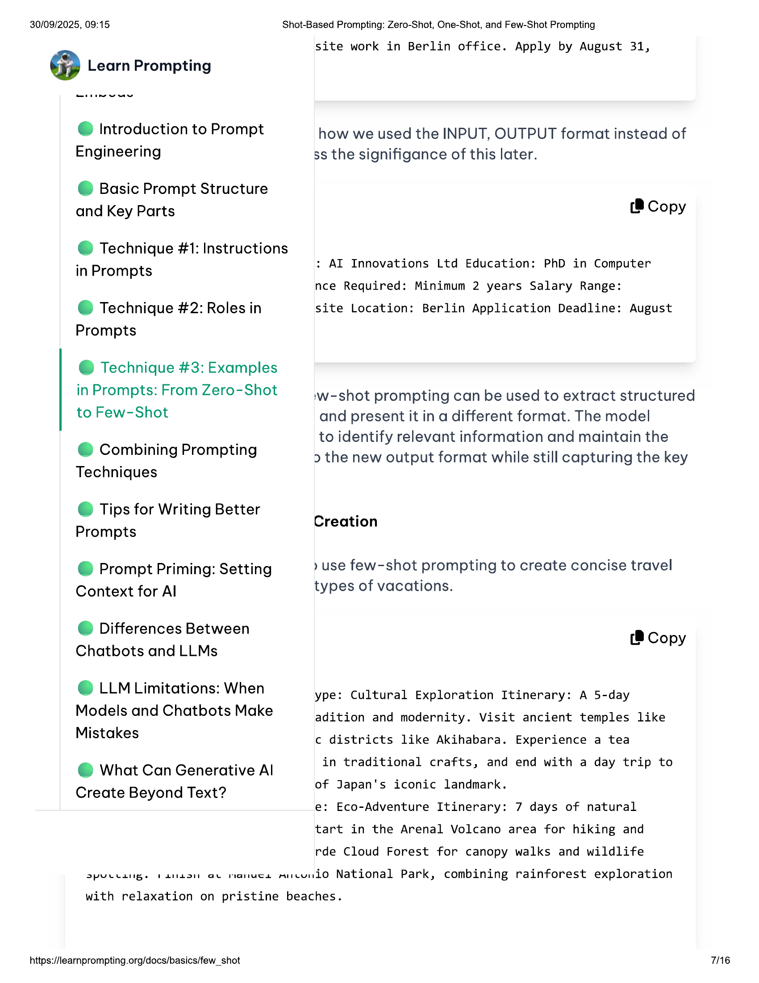

30/09/2025, 09:15  
  
@ Introduction to Prompt  
  
Engineering  
  
© Basic Prompt Structure  
  
and Key Parts  
  
@ Technique #1: Instructions  
  
in Prompts  
  
@ Technique #2: Roles in  
  
Prompts  
  
@ Technique #3: Examples  
in Prompts: From Zero-Shot  
  
to Few-Shot  
  
@ Combining Prompting  
  
Techniques  
  
© Tips for Writing Better  
  
Prompts  
  
@ Prompt Priming: Setting  
  
Context for Al  
  
@ Differences Between  
Chatbots and LLMs  
  
© LLM Limitations: When  
Models and Chatbots Make  
  
Mistakes  
  
@ What Can Generative Al  
  
Create Beyond Text?  
  
Shot-Based Prompting: Zero-Shot, One-Shot, and Few-Shot Prompting  
  
site work in Berlin office. Apply by August 31,  
  
how we used the INPUT, OUTPUT format instead of  
ss the signifigance of this later.  
  
(8 Copy  
  
: AI Innovations Ltd Education: PhD in Computer  
nce Required: Minimum 2 years Salary Range:  
  
site Location: Berlin Application Deadline: August  
  
:w-shot prompting can be used to extract structured  
  
and present it in a different format. The model  
to identify relevant information and maintain the  
> the new output format while still capturing the key  
  
Creation  
  
» use few-shot prompting to create concise travel  
types of vacations.  
  
(8 Copy  
  
ype: Cultural Exploration Itinerary: A 5-day  
adition and modernity. Visit ancient temples like  
c districts like Akihabara. Experience a tea  
  
in traditional crafts, and end with a day trip to  
of Japan's iconic landmark.  
e: Eco-Adventure Itinerary: 7 days of natural  
tart in the Arenal Volcano area for hiking and  
  
rde Cloud Forest for canopy walks and wildlife  
  
>puctange ranacn av ranuca micunio National Park, combining rainforest exploration  
  
with relaxation on pristine beaches.  
  
https://learnprompting.org/docs/basics/few_shot  
  
76

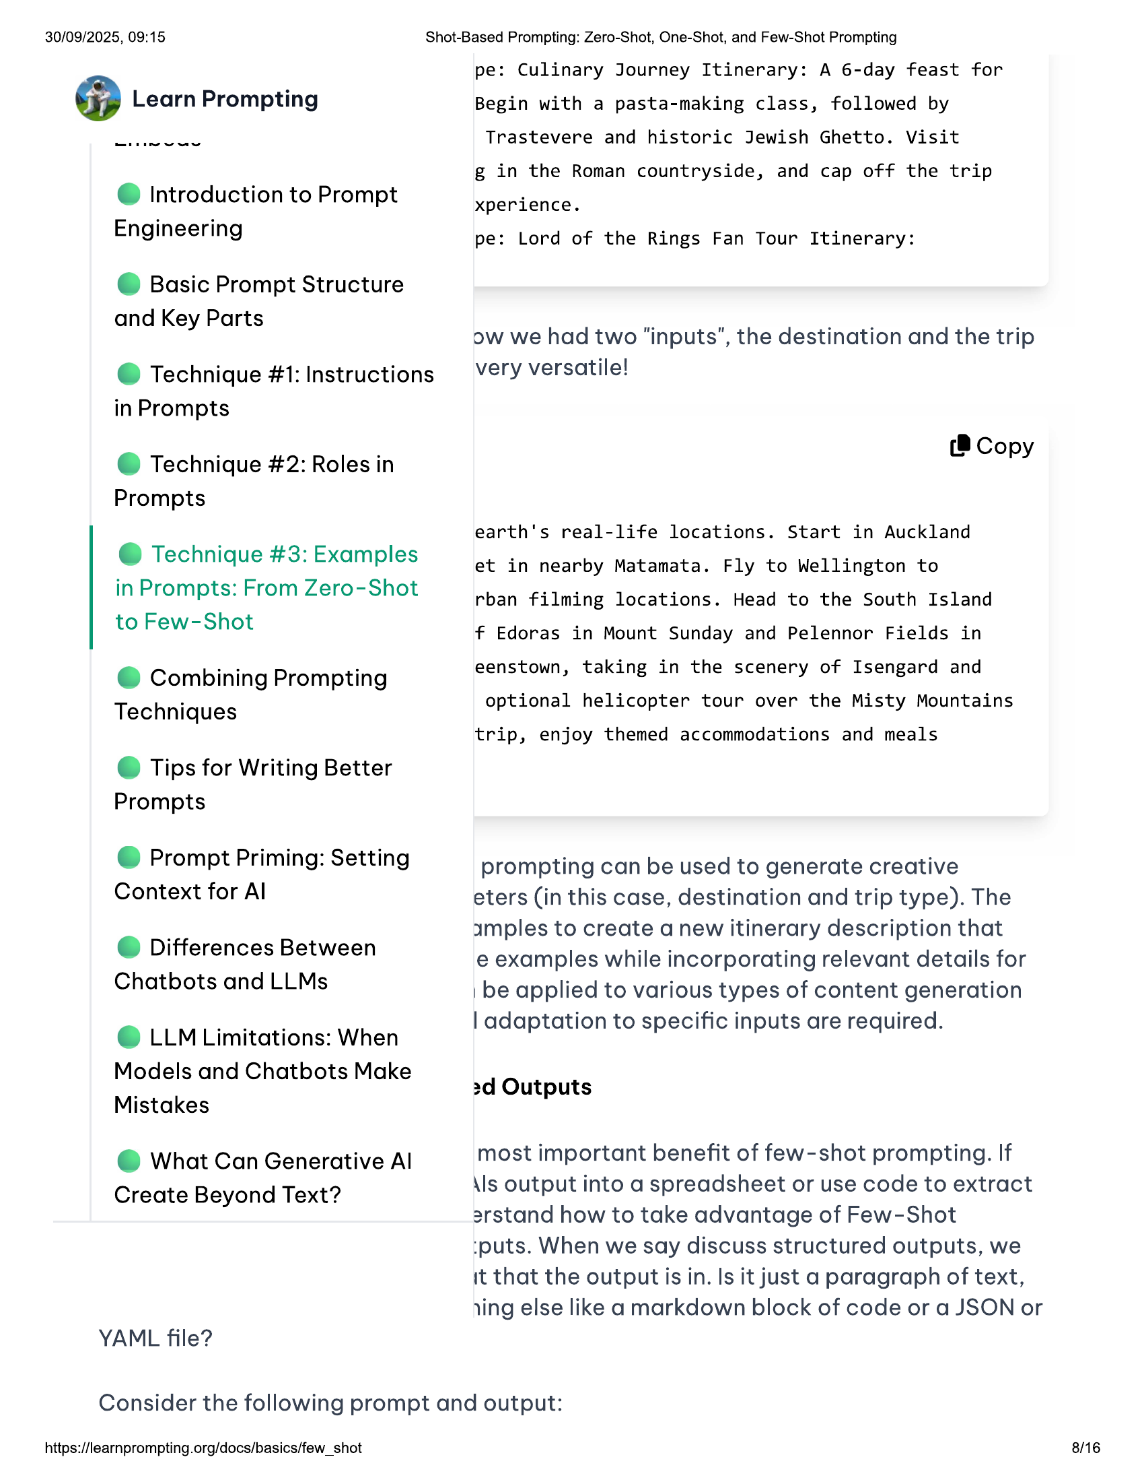

30/09/2025, 09:15  
  
@ Introduction to Prompt  
Engineering  
  
© Basic Prompt Structure  
and Key Parts  
  
@ Technique #1: Instructions  
in Prompts  
  
@ Technique #2: Roles in  
Prompts  
  
@ Technique #3: Examples  
in Prompts: From Zero-Shot  
to Few-Shot  
  
@ Combining Prompting  
Techniques  
  
© Tips for Writing Better  
Prompts  
  
@ Prompt Priming: Setting  
Context for Al  
  
@ Differences Between  
Chatbots and LLMs  
  
© LLM Limitations: When  
Models and Chatbots Make  
Mistakes  
  
@ What Can Generative Al  
Create Beyond Text?  
  
YAML file?  
  
Shot-Based Prompting: Zero-Shot, One-Shot, and Few-Shot Prompting  
  
pe: Culinary Journey Itinerary: A 6-day feast for  
Begin with a pasta-making class, followed by  
Trastevere and historic Jewish Ghetto. Visit  
  
g in the Roman countryside, and cap off the trip  
xperience.  
  
pe: Lord of the Rings Fan Tour Itinerary:  
  
ow we had two “inputs”, the destination and the trip  
very versatile!  
  
(® Copy  
  
earth's real-life locations. Start in Auckland  
  
et in nearby Matamata. Fly to Wellington to  
  
rban filming locations. Head to the South Island  
  
f Edoras in Mount Sunday and Pelennor Fields in  
eenstown, taking in the scenery of Isengard and  
optional helicopter tour over the Misty Mountains  
  
trip, enjoy themed accommodations and meals  
  
prompting can be used to generate creative  
  
eters (in this case, destination and trip type). The  
amples to create a new itinerary description that  
  
e examples while incorporating relevant details for  
| be applied to various types of content generation  
| adaptation to specific inputs are required.  
  
2d Outputs  
  
most important benefit of few-shot prompting. If  
\ls output into a spreadsheet or use code to extract  
2rstand how to take advantage of Few-Shot  
  
:puts. When we say discuss structured outputs, we  
  
it that the output is in. Is it just a paragraph of text,  
jing else like a markdown block of code or a JSON or  
  
Consider the following prompt and output:  
  
https://learnprompting.org/docs/basics/few_shot  
  
8/16

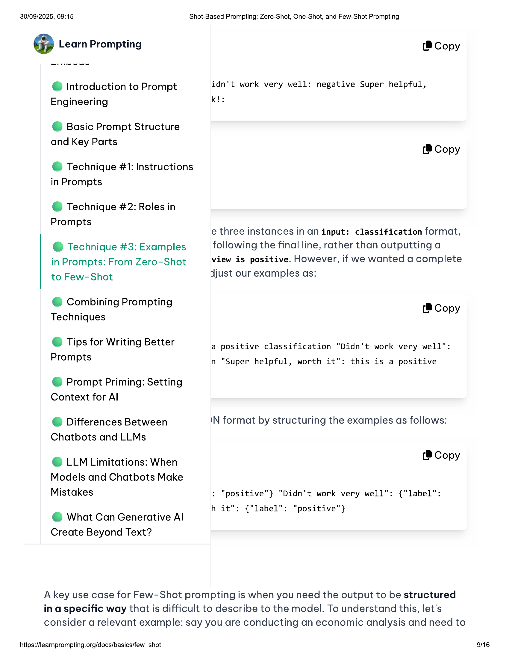

30/09/2025, 09:15 Shot-Based Prompting: Zero-Shot, One-Shot, and Few-Shot Prompting  
  
@ Learn Prompting (® Copy  
e@ Introduction to Prompt idn't work very well: negative Super helpful,  
Engineering kl:  
  
© Basic Prompt Structure  
  
and Key Parts (8 Copy  
  
@ Technique #1: Instructions  
in Prompts  
  
@ Technique #2: Roles in  
  
Prompts  
  
e three instances in an input: classification format,  
@ Technique #3: Examples following the final line, rather than outputting a  
in Prompts: From Zero-Shot view is positive. However, if we wanted a complete  
to Few-Shot djust our examples as:  
  
@ Combining Prompting  
Techniques  
  
(® Copy  
  
© Tips for Writing Better  
Prompts  
  
a positive classification "Didn't work very well":  
n "Super helpful, worth it": this is a positive  
  
@ Prompt Priming: Setting  
Context for Al  
  
@ Differences Between IN format by structuring the examples as follows:  
Chatbots and LLMs  
  
_ Te  
© LLM Limitations: When o copy  
Models and Chatbots Make  
Mistakes : "positive"} "Didn't work very well": {"label":  
  
. h it": {"label": "positive"}  
@ What Can Generative Al  
  
Create Beyond Text?  
  
A key use case for Few-Shot prompting is when you need the output to be structured  
in a specific way that is difficult to describe to the model. To understand this, let's  
consider a relevant example: say you are conducting an economic analysis and need to  
  
https://learnprompting.org/docs/basics/few_shot 9/16

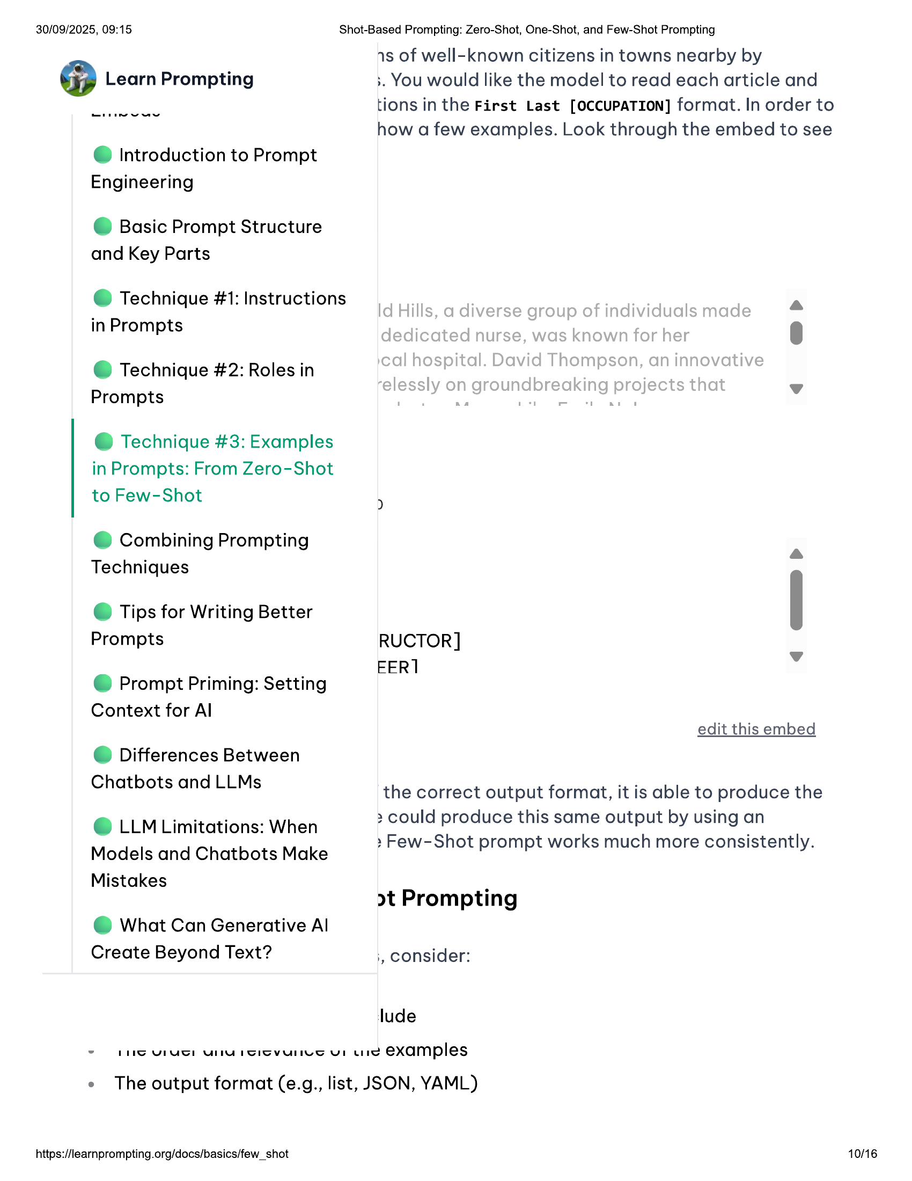

30/09/2025, 09:15 Shot-Based Prompting: Zero-Shot, One-Shot, and Few-Shot Prompting  
1s of well-known citizens in towns nearby by  
@ Learn Prompting ;. You would like the model to read each article and  
tions in the First Last [OCCUPATION] format. In order to  
how a few examples. Look through the embed to see  
  
@ Introduction to Prompt  
Engineering  
  
© Basic Prompt Structure  
and Key Parts  
  
@ Technique #1: Instructions  
in Prompts  
  
@ dD  
  
@ Technique #2: Roles in  
  
Prompts v  
@ Technique #3: Examples  
in Prompts: From Zero-Shot  
to Few-Shot "  
@ Combining Prompting a  
Techniques  
© Tips for Writing Better |  
Prompts RUCTOR]  
  
EER] .  
  
@ Prompt Priming: Setting  
  
Context for Al  
edit this embed  
  
@ Differences Between  
  
Chatbots and LLMs the correct output format, it is able to produce the  
  
> could produce this same output by using an  
  
© LLM Limitations: When -  
» Few-Shot prompt works much more consistently.  
  
Models and Chatbots Make  
  
Mistakes .  
>t Prompting  
  
@ What Can Generative Al  
Create Beyond Text? ;, consider:  
  
lude  
~ FS VIS UU ISISVvUNneS UL Ud examples  
  
e The output format (e.g., list, JSON, YAML)  
  
https://learnprompting.org/docs/basics/few_shot 10/16

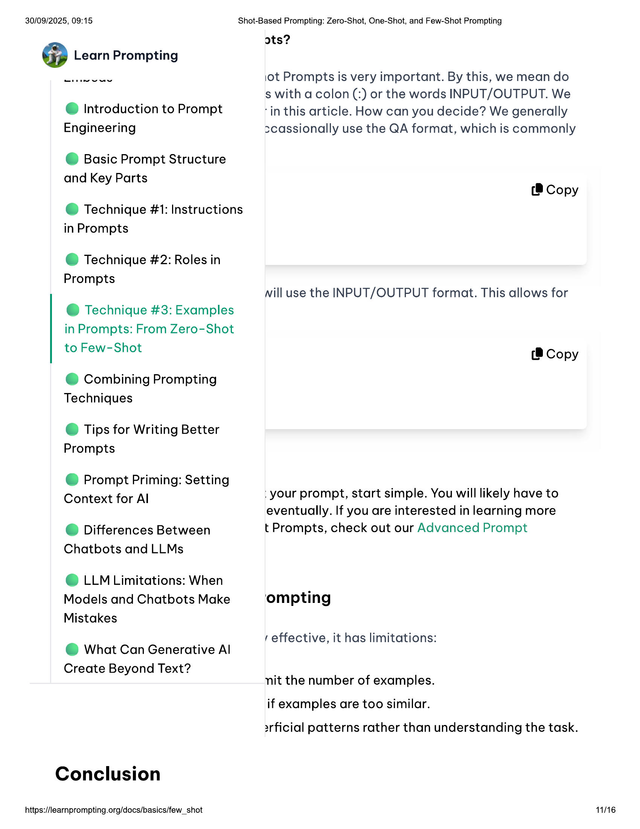

30/09/2025, 09:15  
  
@ Introduction to Prompt  
Engineering  
  
© Basic Prompt Structure  
and Key Parts  
  
@ Technique #1: Instructions  
in Prompts  
  
@ Technique #2: Roles in  
Prompts  
  
@ Technique #3: Examples  
in Prompts: From Zero-Shot  
to Few-Shot  
  
@ Combining Prompting  
Techniques  
  
© Tips for Writing Better  
Prompts  
  
@ Prompt Priming: Setting  
Context for Al  
  
@ Differences Between  
Chatbots and LLMs  
  
© LLM Limitations: When  
Models and Chatbots Make  
Mistakes  
  
@ What Can Generative Al  
Create Beyond Text?  
  
Conclusion  
  
https://learnprompting.org/docs/basics/few_shot  
  
Shot-Based Prompting: Zero-Shot, One-Shot, and Few-Shot Prompting  
  
ots?  
  
1\ot Prompts is very important. By this, we mean do  
s with a colon (:) or the words INPUT/OUTPUT. We  
‘in this article. How can you decide? We generally  
scassionally use the QA format, which is commonly  
  
(8 Copy  
  
ill use the INPUT/OUTPUT format. This allows for  
  
(® Copy  
  
your prompt, start simple. You will likely have to  
eventually. If you are interested in learning more  
t Prompts, check out our Advanced Prompt  
  
ompting  
effective, it has limitations:  
  
nit the number of examples.  
if examples are too similar.  
  
2rficial patterns rather than understanding the task.  
  
11/16

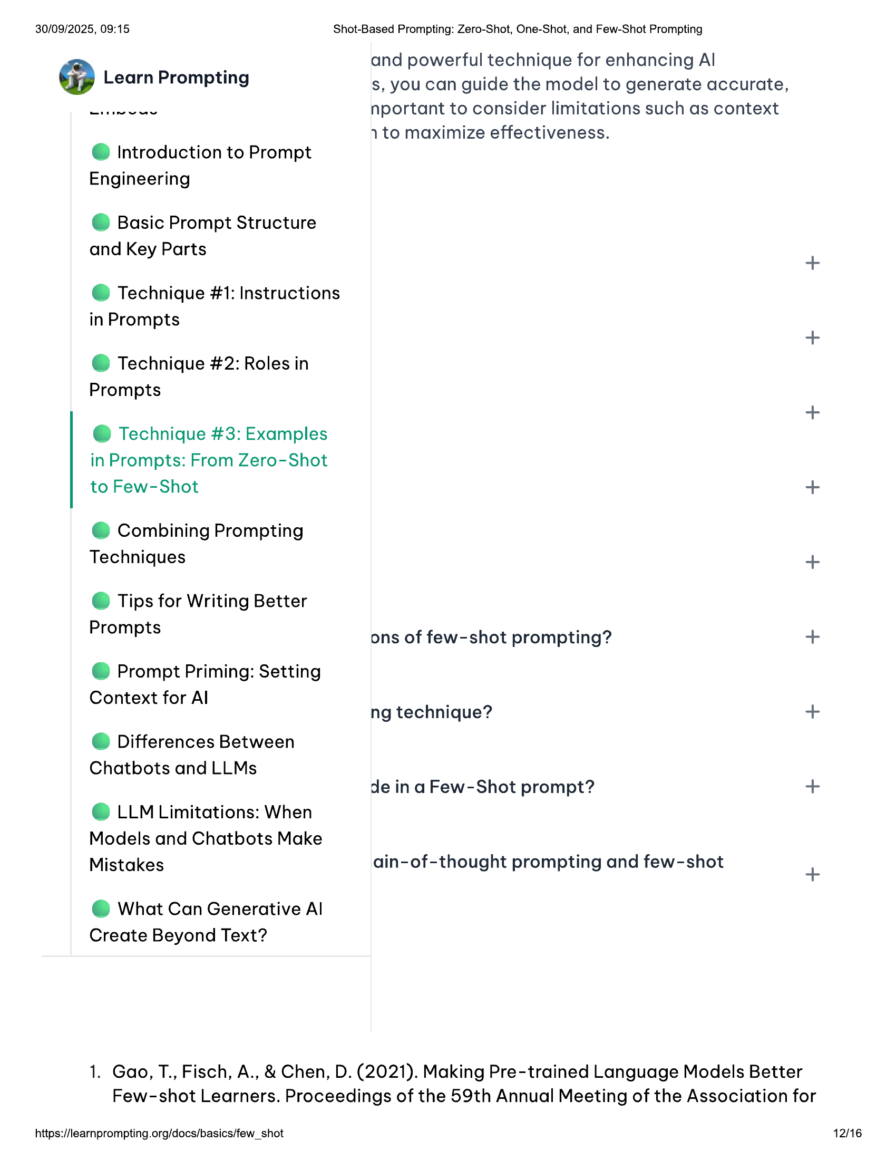

30/09/2025, 09:15  
  
Shot-Based Prompting: Zero-Shot, One-Shot, and Few-Shot Prompting  
  
and powerful technique for enhancing Al  
s, you can guide the model to generate accurate,  
nportant to consider limitations such as context  
  
@ Introduction to Prompt  
Engineering  
  
© Basic Prompt Structure  
and Key Parts  
  
@ Technique #1: Instructions  
  
in Prompts  
  
@ Technique #2: Roles in  
Prompts  
  
@ Technique #3: Examples  
in Prompts: From Zero-Shot  
to Few-Shot  
  
@ Combining Prompting  
Techniques  
  
© Tips for Writing Better  
Prompts  
  
@ Prompt Priming: Setting  
Context for Al  
  
@ Differences Between  
Chatbots and LLMs  
  
© LLM Limitations: When  
Models and Chatbots Make  
Mistakes  
  
@ What Can Generative Al  
Create Beyond Text?  
  
1. Gao, T., Fisch, A., & Chen, D. (2021). Making Pre-trained Language Models Better  
Few-shot Learners. Proceedings of the 59th Annual Meeting of the Association for  
  
https://learnprompting.org/docs/basics/few_shot  
  
1 to maximize effectiveness.  
  
ons of few-shot prompting?  
  
ng technique?  
  
de in a Few-Shot prompt?  
  
ain-of-thought prompting and few-shot  
  
12/16

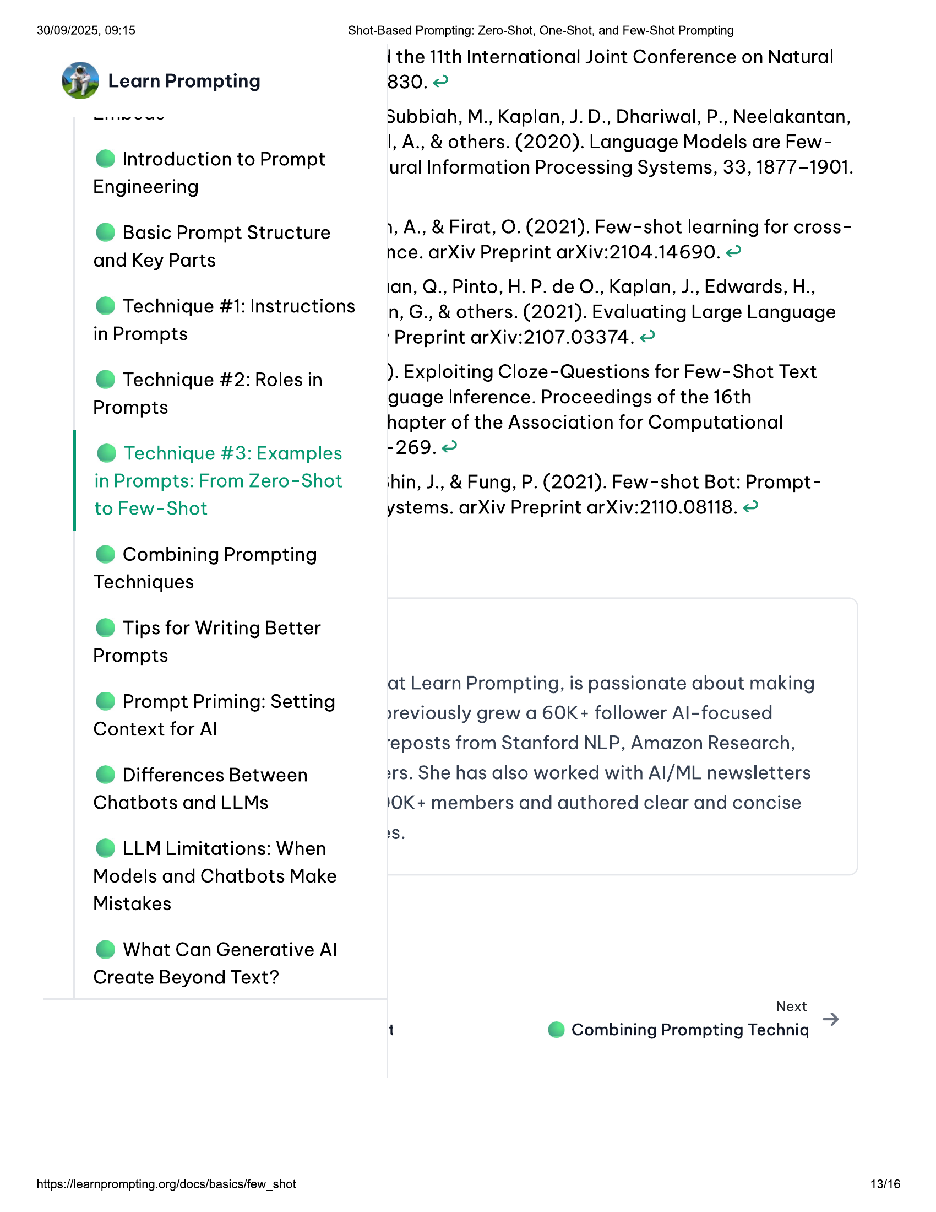

30/09/2025, 09:15  
  
@ Introduction to Prompt  
Engineering  
  
© Basic Prompt Structure  
and Key Parts  
  
@ Technique #1: Instructions  
in Prompts  
  
@ Technique #2: Roles in  
Prompts  
  
@ Technique #3: Examples  
in Prompts: From Zero-Shot  
to Few-Shot  
  
@ Combining Prompting  
Techniques  
  
© Tips for Writing Better  
Prompts  
  
@ Prompt Priming: Setting  
Context for Al  
  
@ Differences Between  
Chatbots and LLMs  
  
© LLM Limitations: When  
Models and Chatbots Make  
Mistakes  
  
@ What Can Generative Al  
Create Beyond Text?  
  
https://learnprompting.org/docs/basics/few_shot  
  
Shot-Based Prompting: Zero-Shot, One-Shot, and Few-Shot Prompting  
  
| the 11th International Joint Conference on Natural  
830. 2  
  
Subbiah, M., Kaplan, J. D., Dhariwal, P., Neelakantan,  
|, A., & others. (2020). Language Models are Few-  
  
ural Information Processing Systems, 33, 1877-1901.  
  
1, A., & Firat, O. (2021). Few-shot learning for cross-  
nce. arXiv Preprint arXiv:2104.14690. ©  
  
ian, Q., Pinto, H. P. de O., Kaplan, J., Edwards, H.,  
n, G., & others. (2021). Evaluating Large Language  
Preprint arXiv:2107.03374. ©  
  
). Exploiting Cloze-Questions for Few-Shot Text  
guage Inference. Proceedings of the 16th  
  
hapter of the Association for Computational  
-269.2  
  
thin, J., & Fung, P. (2021). Few-shot Bot: Prompt-  
ystems. arXiv Preprint arXiv:2110.08118. ©  
  
at Learn Prompting, is passionate about making  
»yreviously grew a 60K+ follower Al-focused  
‘eposts from Stanford NLP, Amazon Research,  
»rs. She has also worked with Al/ML newsletters  
\OK+ members and authored clear and concise  
1S.  
  
Next  
t @ Combining Prompting Techni  
  
13/16

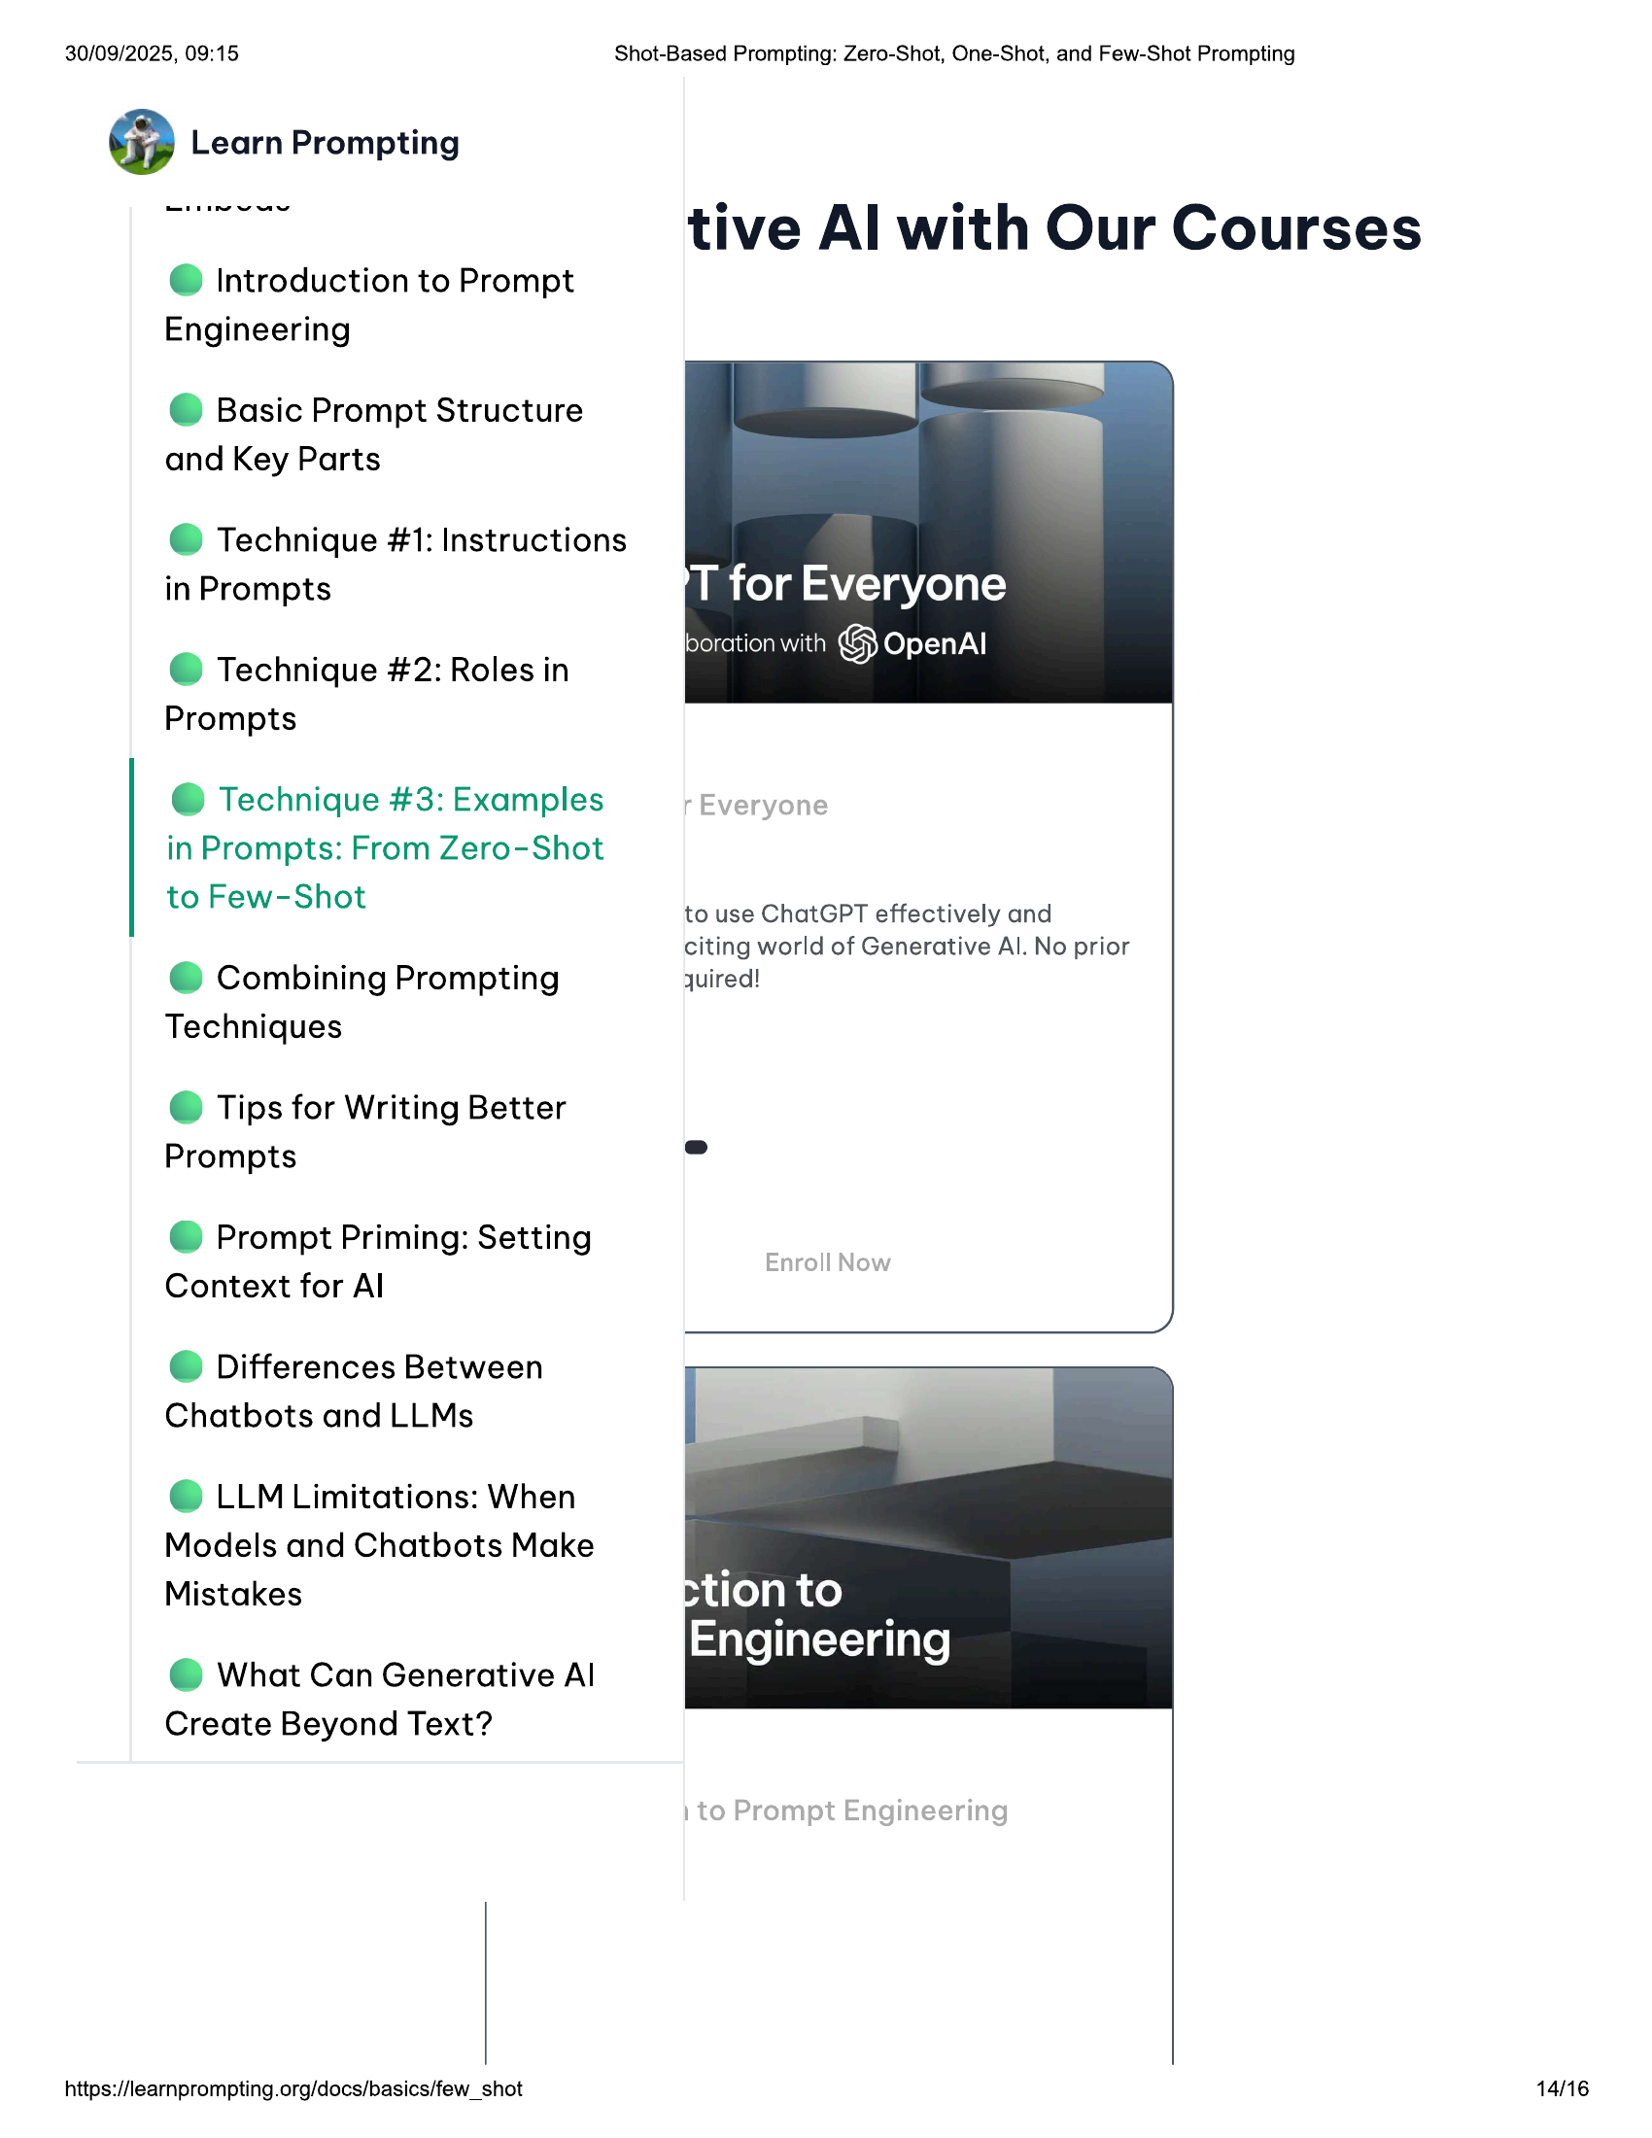

30/09/2025, 09:15 Shot-Based Prompting: Zero-Shot, One-Shot, and Few-Shot Prompting  
  
tive Al with Our Courses  
  
@ Introduction to Prompt  
Engineering  
  
© Basic Prompt Structure  
and Key Parts  
  
@ Technique #1: Instructions  
in Prompts  
  
@ Technique #2: Roles in  
Prompts  
  
@ Technique #3: Examples  
in Prompts: From Zero-Shot  
  
to Few-Shot to use ChatGPT effectively and  
  
citing world of Generative Al. No prior  
@ Combining Prompting quired!  
Techniques  
  
© Tips for Writing Better  
Prompts  
  
@ Prompt Priming: Setting  
Context for Al  
  
@ Differences Between  
Chatbots and LLMs  
  
© LLM Limitations: When  
Models and Chatbots Make  
Mistakes  
  
@ What Can Generative Al  
Create Beyond Text?  
  
https://learnprompting.org/docs/basics/few_shot 14/16

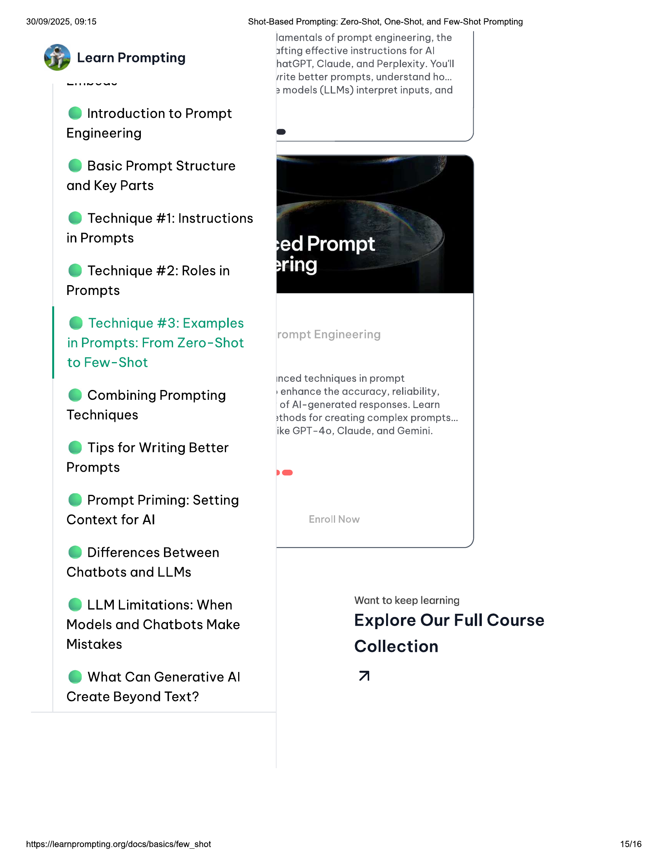

30/09/2025, 09:15 Shot-Based Prompting: Zero-Shot, One-Shot, and Few-Shot Prompting  
  
lamentals of prompt engineering, the  
  
* afting effective instructions for Al  
@ Learn Prompting hatGPT, Claude, and Perplexity. You'll  
srite better prompts, understand ho...  
3 models (LLMs) interpret inputs, and  
  
@ Introduction to Prompt  
Engineering  
  
© Basic Prompt Structure  
and Key Parts  
  
@ Technique #1: Instructions  
in Prompts  
  
@ Technique #2: Roles in  
Prompts  
  
@ Technique #3: Examples  
in Prompts: From Zero-Shot  
  
to Few-Shot  
inced techniques in prompt  
e Combining Prompting »enhance the accuracy, reliability,  
. of Al-generated responses. Learn  
Techniques sthods for creating complex prompts...  
  
ike GPT-40, Claude, and Gemini.  
© Tips for Writing Better  
Prompts be  
  
@ Prompt Priming: Setting  
Context for Al  
  
)  
@ Differences Between  
Chatbots and LLMs  
@ LLM Limitations: When Want to keep learning  
Models and Chatbots Make Explore Our Full Course  
Mistakes Collection  
@ What Can Generative Al a  
  
Create Beyond Text?  
  
https://learnprompting.org/docs/basics/few_shot 15/16

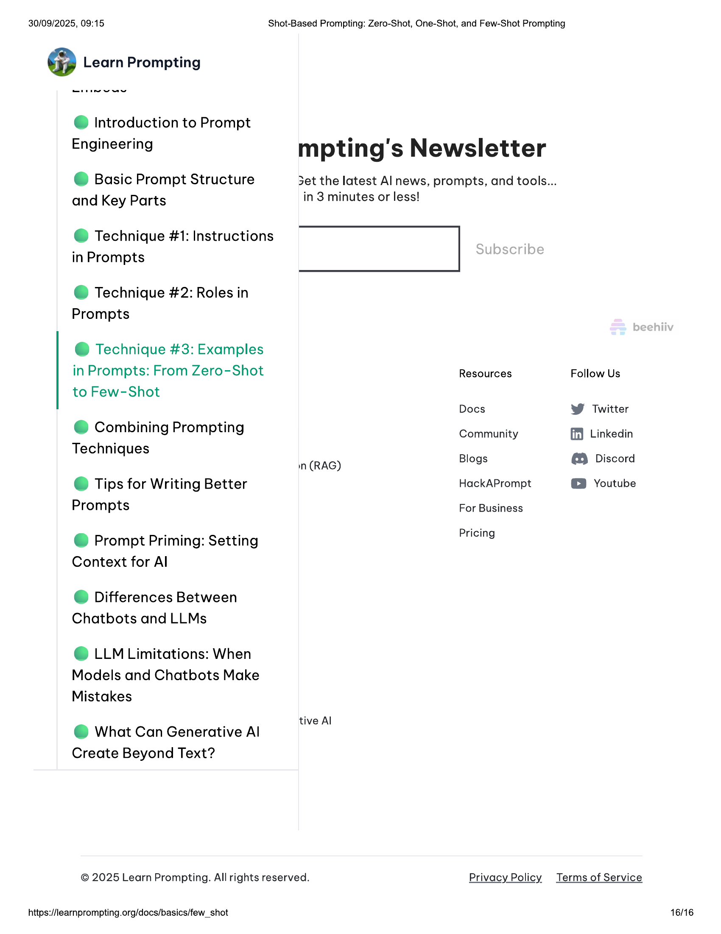

30/09/2025, 09:15 Shot-Based Prompting: Zero-Shot, One-Shot, and Few-Shot Prompting  
  
@ Introduction to Prompt  
  
. . e ii  
  
Engineering mpting's Newsletter  
© Basic Prompt Structure Set the latest Al news, prompts, and tools...  
and Key Parts in 3 minutes or less!  
  
@ Technique #1: Instructions  
in Prompts  
  
@ Technique #2: Roles in  
Prompts  
  
@ Technique #3: Examples  
  
in Prompts: From Zero-Shot Resources Follow Us  
to Few-Shot  
  
Docs W Twitter  
e Combining Prompting Community ff} Linkedin  
Techniques :  
  
in (RAG) Blogs @ Discord  
  
© Tips for Writing Better HackAPrompt © Youtube  
Prompts For Business  
  
Pricing  
  
@ Prompt Priming: Setting  
Context for Al  
  
@ Differences Between  
Chatbots and LLMs  
  
© LLM Limitations: When  
Models and Chatbots Make  
  
Mistakes  
. tive Al  
@ What Can Generative Al  
Create Beyond Text?  
© 2025 Learn Prompting. All rights reserved. Privacy Policy Terms of Service  
  
https://learnprompting.org/docs/basics/few_shot  
  
16/16